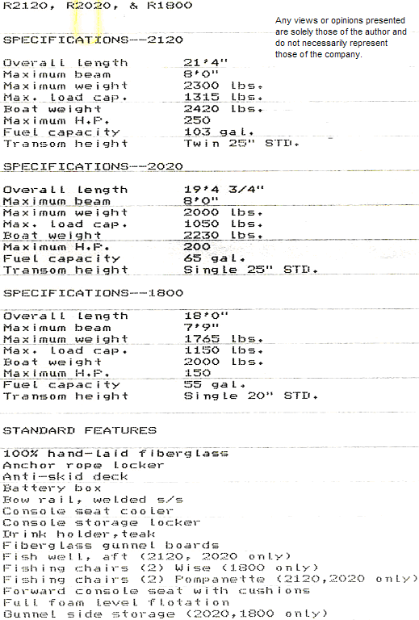
http://www.geocities.com/mrrobalo/
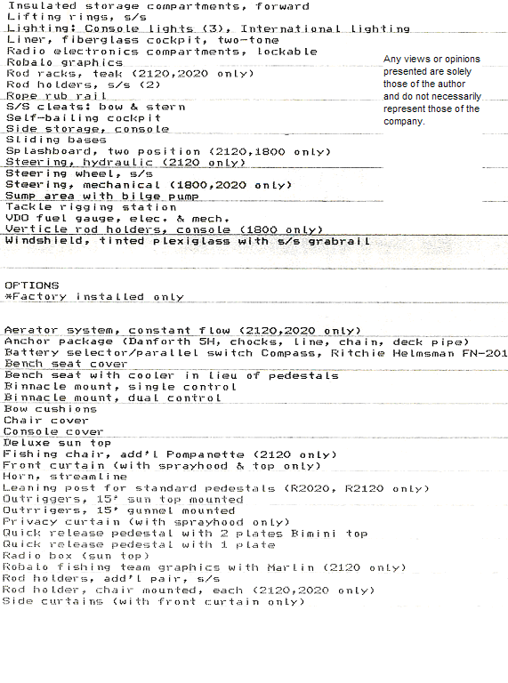
Spray-hood with screen
Steering, hydraulic (2020, 1800 only, std. on 2120)
Teak appearance package: gunnel boards, splash-wells, battery box covers, fish-well covers
Teak transom platform
Teak pulpit board with s/s bow-rail
Wash-down pump (2120, 2120 only)

http://www.geocities.com/mrrobalo/
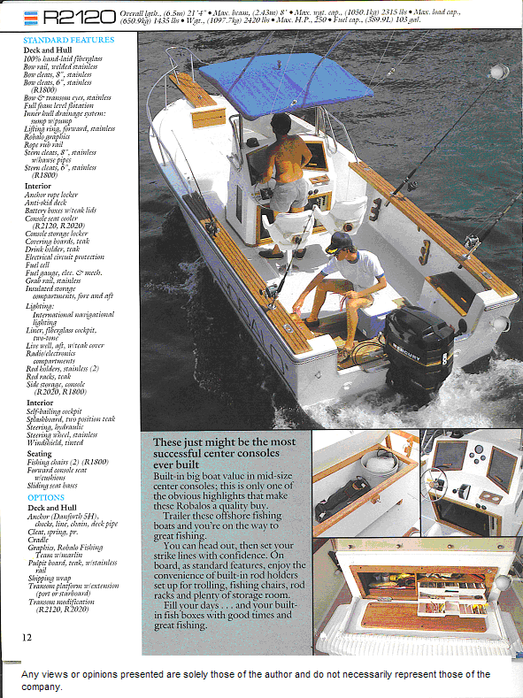
http://www.geocities.com/mrrobalo/
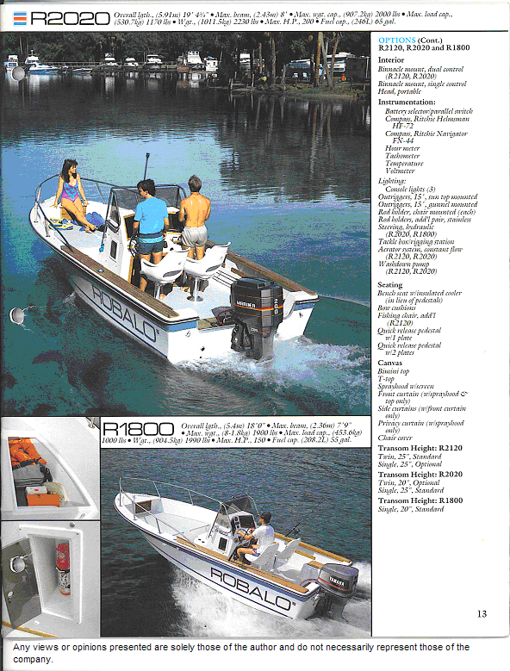
http://www.geocities.com/mrrobalo/

